Namibia

## Population Data

The data set shows the political stability estimate of the country each year.

## # A tibble: 23 x 5  
## country iso3c date population popCategory5  
## <chr> <chr> <dbl> <dbl> <chr>   
## 1 Namibia NAM 1996 1663378 very small   
## 2 Namibia NAM 1997 1698032 very small   
## 3 Namibia NAM 1998 1731639 very small   
## 4 Namibia NAM 1999 1763859 very small   
## 5 Namibia NAM 2000 1794571 very small   
## 6 Namibia NAM 2001 1823672 very small   
## 7 Namibia NAM 2002 1851523 very small   
## 8 Namibia NAM 2003 1879117 very small   
## 9 Namibia NAM 2004 1907745 very small   
## 10 Namibia NAM 2005 1938320 very small   
## 11 Namibia NAM 2006 1971317 very small   
## 12 Namibia NAM 2007 2006514 very small   
## 13 Namibia NAM 2008 2043394 very small   
## 14 Namibia NAM 2009 2081044 very small   
## 15 Namibia NAM 2010 2118874 very small   
## 16 Namibia NAM 2011 2156701 very small   
## 17 Namibia NAM 2012 2194784 very small   
## 18 Namibia NAM 2013 2233510 very small   
## 19 Namibia NAM 2014 2273430 very small   
## 20 Namibia NAM 2015 2314904 very small   
## 21 Namibia NAM 2016 2358041 very small   
## 22 Namibia NAM 2017 2402603 very small   
## 23 Namibia NAM 2018 2448255 very small

# Population growth data

## # A tibble: 23 x 5  
## country iso3c date popGrowth popGrowthCat5   
## <chr> <chr> <dbl> <dbl> <chr>   
## 1 Namibia NAM 1996 2.16 moderate growth rate  
## 2 Namibia NAM 1997 2.06 moderate growth rate  
## 3 Namibia NAM 1998 1.96 moderate growth rate  
## 4 Namibia NAM 1999 1.84 moderate growth rate  
## 5 Namibia NAM 2000 1.73 moderate growth rate  
## 6 Namibia NAM 2001 1.61 moderate growth rate  
## 7 Namibia NAM 2002 1.52 moderate growth rate  
## 8 Namibia NAM 2003 1.48 slow growth rate   
## 9 Namibia NAM 2004 1.51 moderate growth rate  
## 10 Namibia NAM 2005 1.59 moderate growth rate  
## 11 Namibia NAM 2006 1.69 moderate growth rate  
## 12 Namibia NAM 2007 1.77 moderate growth rate  
## 13 Namibia NAM 2008 1.82 moderate growth rate  
## 14 Namibia NAM 2009 1.83 moderate growth rate  
## 15 Namibia NAM 2010 1.80 moderate growth rate  
## 16 Namibia NAM 2011 1.77 moderate growth rate  
## 17 Namibia NAM 2012 1.75 moderate growth rate  
## 18 Namibia NAM 2013 1.75 moderate growth rate  
## 19 Namibia NAM 2014 1.77 moderate growth rate  
## 20 Namibia NAM 2015 1.81 moderate growth rate  
## 21 Namibia NAM 2016 1.85 moderate growth rate  
## 22 Namibia NAM 2017 1.87 moderate growth rate  
## 23 Namibia NAM 2018 1.88 moderate growth rate

## Population trend

The plot shows the population trend of the country.

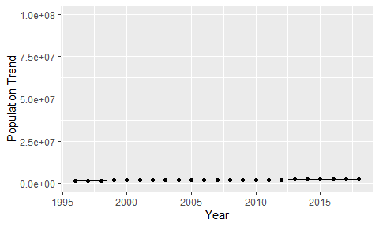

Political Stability Trend

# Population growth trend

The plot shows the population growth rate trend of the country.

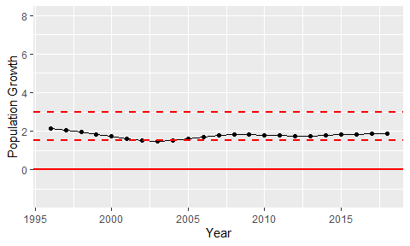

Population Growth Trend